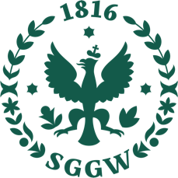
17th MAY 2023, Warsaw
Representatives of the Scientific Club of International Economics in cooperation with the Institute of Economics and Finance of Warsaw University of Life Sciences – SGGW / Department of International Economics and Agribusiness are pleased to invite you to take part in the 3rd INTERNATIONAL SCIETIFIC CONFERENCE: CONTEMPORARY PROBLEMS IN INTERNATIONAL ECONOMICS
Conference topics
- International Trade
- International Finances
- International Economic Relations
- World Economy
- International Business
- Global Stock Market Trading

Conference proceedings
Invitation of participants to whole event is FREE OF CHARGE. The conference will take place on May, 17th 2023 from 14 o’clock (UTC +2 ) at Warsaw University of Life Sciences.
Step necessary to register for the conference as an active participant (conference speaker):
To register using the form below:
https://docs.google.com/forms/d/19iAKoGdHcsfIUDZlwY5NmjmDRTj5LS4OB7L8iHL_VII/edit
The above-metioned activites should be performed by May 10th (we will not extend this deadline).
Scientific Committee:
- dr hab. inż. Jakub Kraciuk, prof. SGGW
- dr hab. Marcin Ratajczak
- dr hab. Mariusz Hamulczuk
- dr inż. Elżbieta Kacperska
- dr Iwona Pomianek
- dr Monika Utzig
- dr Joanna Stefańczyk

Organizing Committee:
- mgr Krzysztof Śnieżko
- mgr inż. Magdalena Kondej
If you have any questions do not hesitate to contact us using following address email: knem@sggw.edu.pl

